20-05-2024

Dynamo DB

Manage Backup, Monitor, Export or import

URLS

<https://docs.aws.amazon.com/amazondynamodb/latest/developerguide/S3DataImport.Format.html>

<https://aws.amazon.com/blogs/database/amazon-dynamodb-can-now-import-amazon-s3-data-into-a-new-table>

Note : DynamoDB import from S3 helps you to bulk import terabytes of data from Amazon S3 into a new DynamoDB table with no code or servers required. Combined with the table export to S3 feature, you can now more easily move, transform, and copy your DynamoDB tables from one application, account, or AWS Region to another. Legacy application data staged in CSV, DynamoDB JSON, or ION format can be imported to DynamoDB, accelerating cloud application migrations.

## Import data from S3 to DynamoDB

Now that you know the basics of DynamoDB import from S3, let’s use it to move data from Amazon S3 to a new DynamoDB table. You can download and deploy a set of [sample JSON files](https://aws-blogs-artifacts-public.s3.amazonaws.com/artifacts/DBBLOG-1951/DynamoDB_S3_Import_SampleData.zip) into your S3 bucket to get started. For this walkthrough, let’s assume you staged these uncompressed DynamoDB JSON data files in an S3 bucket called s3-import-demo in the folder path /demo, as shown in Figure 1 that follows.

Amazon DynamoDB Accelerator (DAX) is a fully-managed, highly-available, in-memory caching service for DynamoDB

Lab

Go to AWS Console and Select the DynamoDB

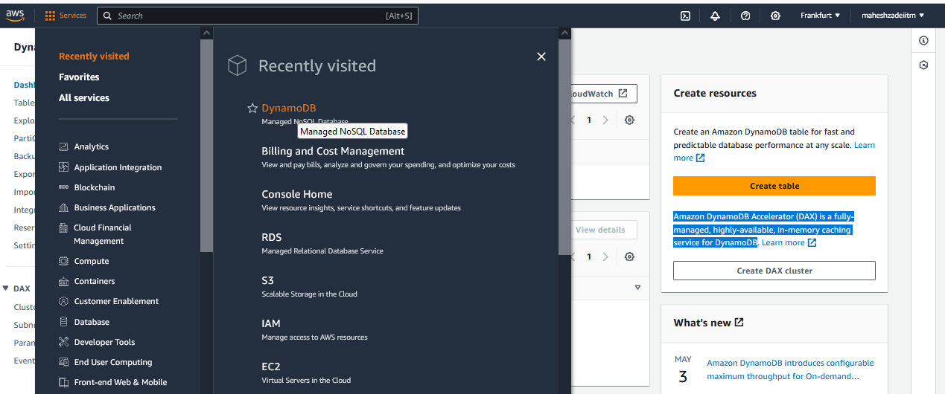

Click on create Table

1 - Download the files from below URL to the local machine

https://aws.amazon.com/blogs/database/amazon-dynamodb-can-now-import-amazon-s3-data-into-a-new-table/

Give the Table name , Partition Key and sort key ( PK and SK for Ex.)

Table Name as : Resource Table

Partition key as -PK

Sort key as -SK

Partition key

The partition key is part of the table's primary key. It is a hash value that is used to retrieve items from your table and allocate data across hosts for scalability and availability.

Sort key - *optional*

You can use a sort key as the second part of a table's primary key. The sort key allows you to sort or search among all items sharing the same partition key.

Keep all the options by default and click on create Table.

**Wait till the table is creating**

**Table created and click on the tabe created**

**Click on explore table items**

**Click on create item**

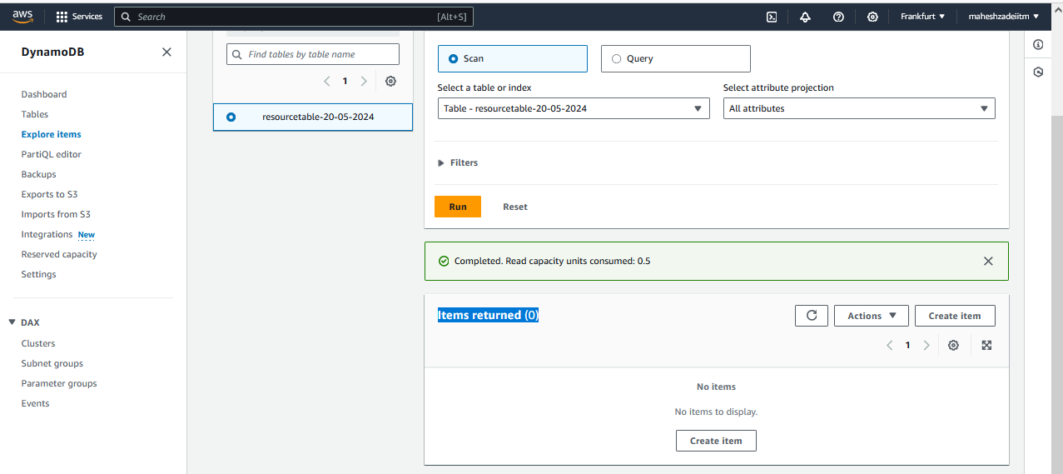

**After this we need keep adding the items manually**

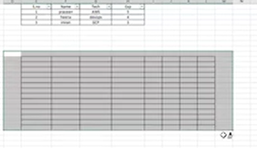

**Do we have anything automated?**

**Call your developer he will create a JSON file .**

**Click on JSON view**

**There is something else in Dynamo DB**

**Go to below url**

[**https://docs.aws.amazon.com/amazondynamodb/latest/developerguide/S3DataImport.Format.html**](https://docs.aws.amazon.com/amazondynamodb/latest/developerguide/S3DataImport.Format.html)

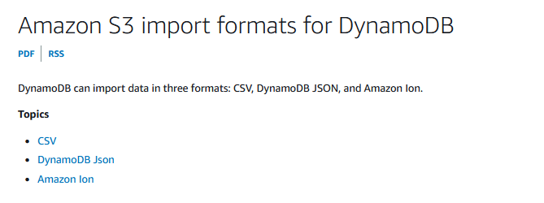



**Who is coming the devops**

**There should be two guys for devops**



**Since it’s a incorrect data entry**

**Go to the DynamoDB an select the import from S3**

**Now go to below AWS Documentation Available**

[**https://aws.amazon.com/blogs/database/amazon-dynamodb-can-now-import-amazon-s3-data-into-a-new-table/**](https://aws.amazon.com/blogs/database/amazon-dynamodb-can-now-import-amazon-s3-data-into-a-new-table/)

**Scroll down**

**Click on sample JSON file where we download the data files**

**Donloaded the sample JSON file**

**And extract all files**

**And open the files**

**Data 1 is perfect**

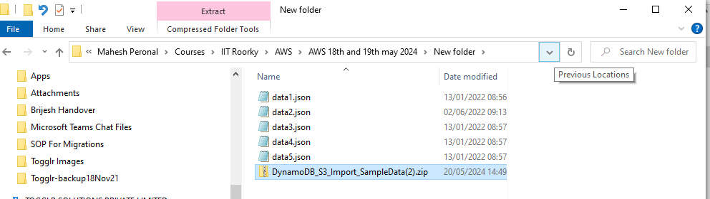

**Dat 2 should fail**

**Pls upload all the files in the S3 Bucket in the same region**

**Go to S3 Bucket**

**Then go to the import from S3**

**Import from S3 button**

**Choose your s3 URL**

**Now go to S3 bucket in Frankfurt region**

**Click on create bucket**

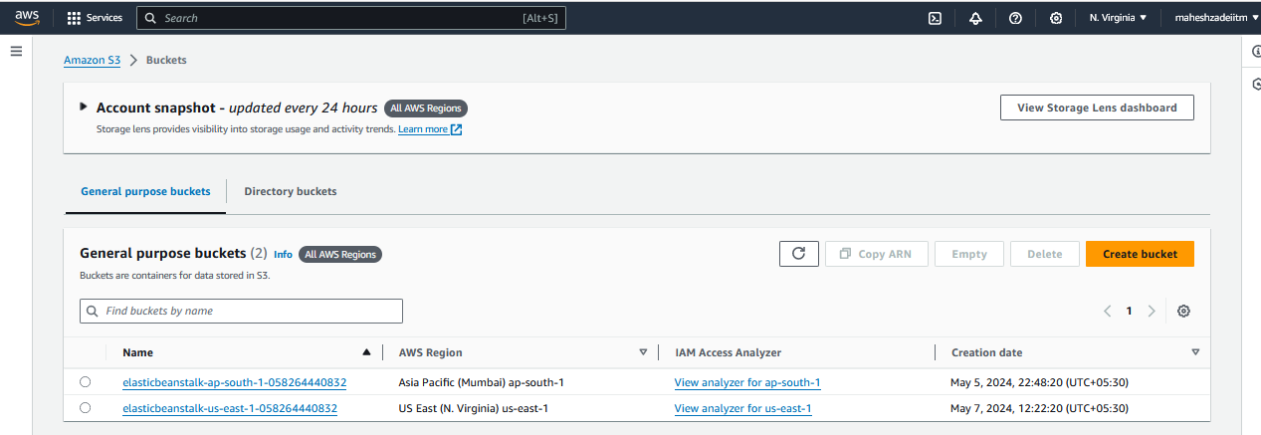

**Give the bucketname as DynamoDBmahesh-20-05-2024**

**Clcik on create bucket**

**Select the bucket**

**Crate a folde as demo or any name**

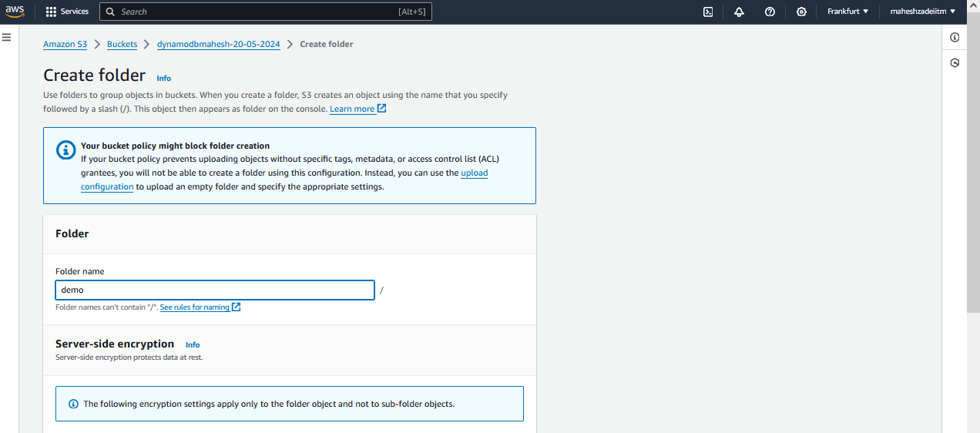

**Now go to the demo folde and upload the files**

**Click on uplod**

**Upload the JSON files which are downloaded above**

**Click on upload**

**Note down the S3 url destination**

[s3://dynamodbmahesh-20-05-2024/demo/](https://eu-central-1.console.aws.amazon.com/s3/buckets/dynamodbmahesh-20-05-2024?region=eu-central-1&bucketType=general&prefix=demo/)

**Upload successfully JSON files**

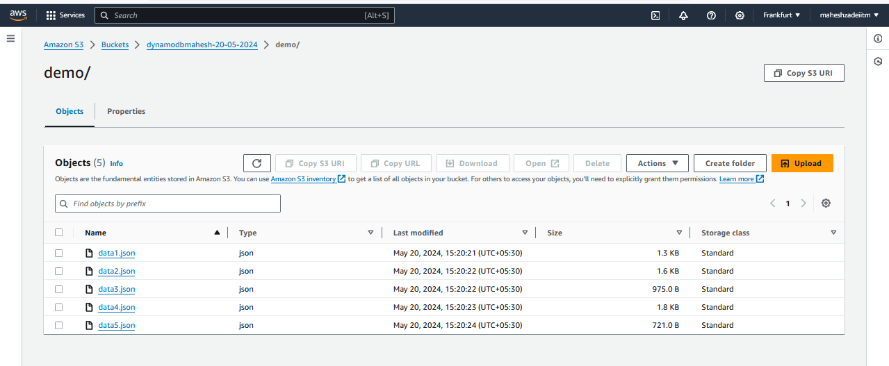

**Go to DynamoDB and select the import from S3**

**Click on import from S3**

**Click on Browse S3**

**Choose bucket**

**Select the folder**

**Choose the demo folder**

**Click on Next**

**Give the table name , partion ket and sort key**

**Click on next**

Review and import

Go to Table

Lab is Successful

Some of the items are not correct ( json files are not correct )

Go to the table and is showing active

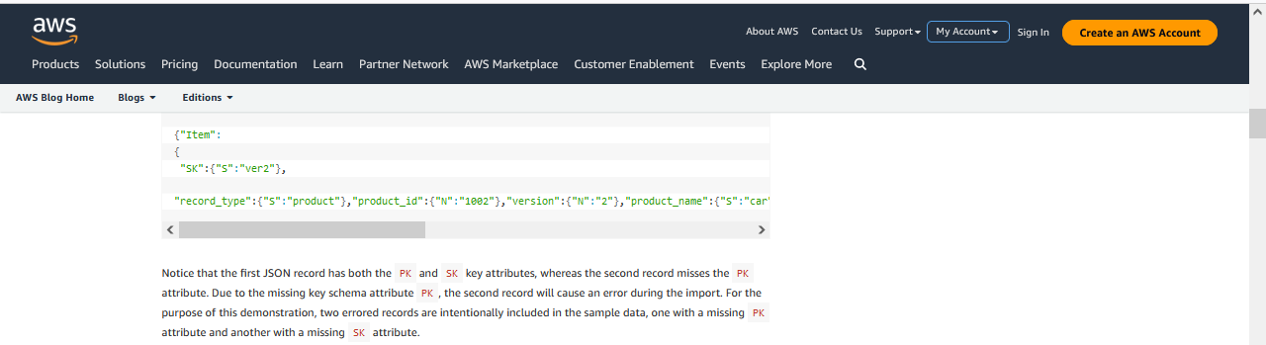

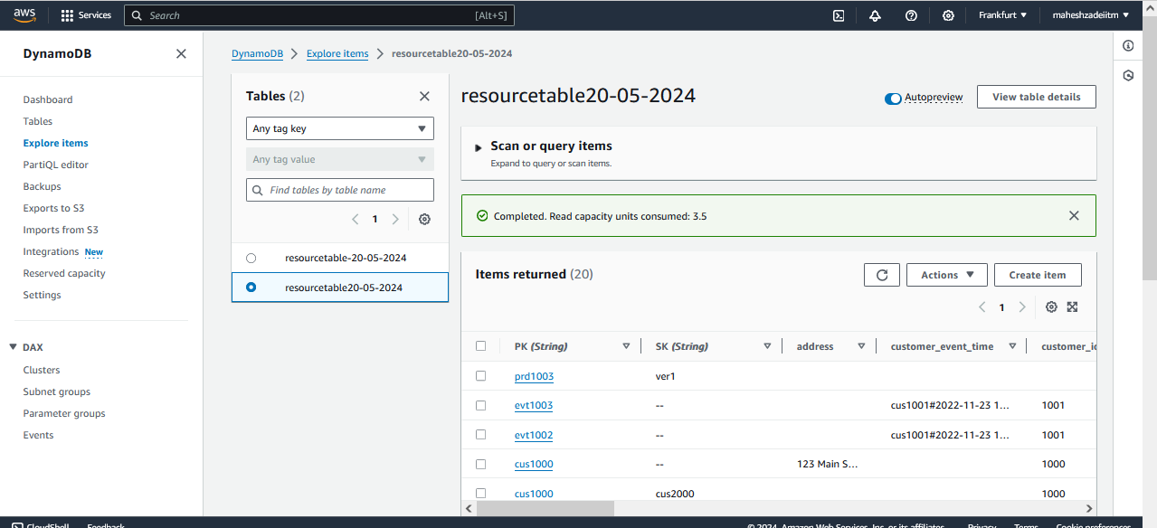

Hands on done Successfully.

Pls check and confirm.

Thanks

2 - Unzip the files and upload into the S3 bucket

you should already having a S3 Bucket, if not create one with default settings

But make sure, there is a folder called "demo" or any other name in the S3.

Upload the files inside that Folder.

Also, make sure, bucket and the DynamoDB both should be in same Region